User Manual

Experience Transcript

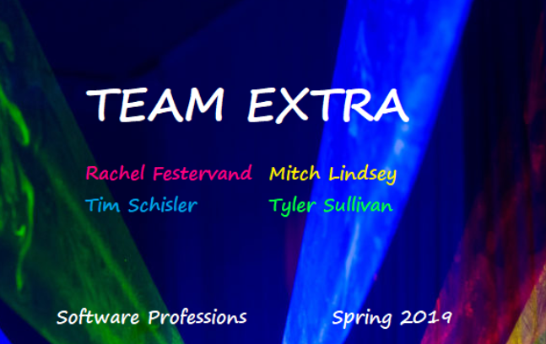

UMSL UNIVERSITY

**Introduction** **3**

**Access Website** **3**

**Add an Enrichment Experience** **4**

**Get a Transcript** **5**

**Prepare Database for Presentation** **6**

# **Introduction**

Currently, this is our “Proof of Concept” website. This website demonstrates the idea of the Experience Transcript. It is designed to be repurposed for additional iterations of the project. This manual will describe how to user or Portal

# **Access Website**

Type extratranscripts.00webhostapp.com in your browser

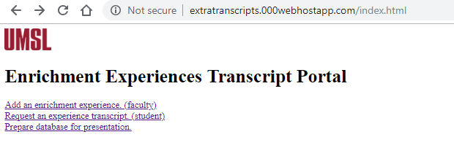

# **Add an Enrichment Experience**

Select the Enrichment Experience link

The form has an option for adding multiple student SSOIDs or individual SSOID

Title is the title for the description of the experience, the Description is a longer explanation of the experience.

All fields are required except Organization.

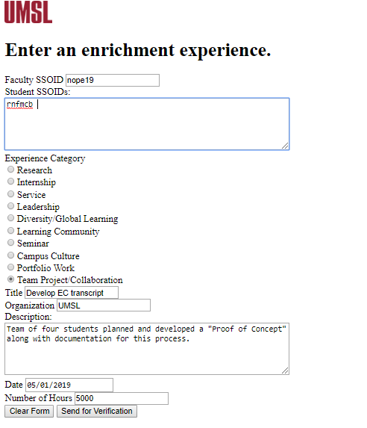

# **Get a Transcript**

Select the “Get an Experience Transcript” link

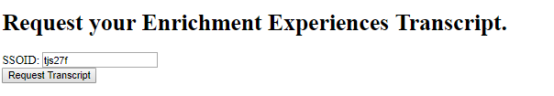

Enter SSOID and “Request Transcript” button

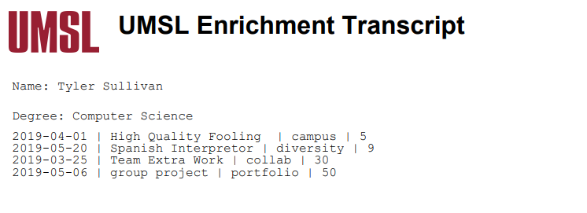

# 

# **Prepare Database for Presentation**

The database for presentation link is for creating the initial database for our portal. Currently, selecting the link will lead to links for the initial database. Since the database is already created, selecting the links will create an error. In the final project, these links would be hidden.

